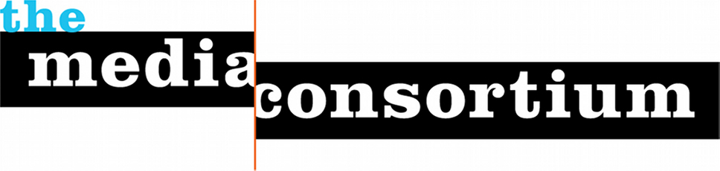

The Media Consortium (www.themediaconsortium.org) is a fiscally sponsored 501c3 network of independent and community media outlets dedicated to values-driven journalism.

Our Mission
The Media Consortium’s mission is to support and grow the impact of the independent and community news sector.

Our Vision
The most trusted news comes from sources that are most authentic to our communities. It’s the podcaster who sounds like our friends, the Youtube show that speaks deeply to our ethnicity or heritage, or the website that keeps us up to date on the issues we care most passionately about. We trust the news that is produced by people who understand who we are.

The members of the Media Consortium are mission-based, values-driven, community-centered outlets. Through alliances with sibling associations, we seek to bring together local journalists, working within particular geographies and demographies, with national journalists working within national demographies and areas of interest in order to create ongoing equitable local-national partnerships. We envision building a bottom-up news network that begins with and centers on these trusted community-based outlets.

At a time when democracy is threatened abroad and at home, we are focused on building a trusted infrastructure of news outlets that will connect us to the core values that Americans still hold true: freedom, equality, respect for the land and opportunity for all. These are the values that lead us to support immigrants, address climate change, protect Black Lives and Black votes, and protect women’s right to choose. These are the values that help our communities thrive and make our lives worth living.

Our History
The Media Consortium was founded in 2006. The country was at war in Iraq and Afghanistan under President George W. Bush. Media was under siege as the digital revolution upended old business models. The Media Consortium’s founders believed the only way to respond to this new environment was to work together, and so they founded a consortium, a member-run network. Though we now have full-time staff, the Media Consortium continues to be a member-led network.
Membership
The Media Consortium currently has 80 member outlets. We have prioritized slow, deliberate growth because making connections between existing members has been our primary focus.

To become a Media Consortium member, an outlet must meet these criteria:
- Be organized as an independent entity mission-driven to serve the public.
Just over 75% of Media Consortium members are 501c3 non-profits. For-profit members must prove that they are organized to serve stakeholders rather than shareholders.
- Produce regular, original, fact-based reporting.
Reporting must be original to the outlet, credible, and fact-based.
- Promote social, racial, and economic justice.
Members commit to pursing these values as they apply to hiring practices, audience outreach, editorial policies, and ownership.

Current Members:
AlterNet | Earth Island Journal | Ms. | Rethinking Schools
American Prospect | Feet in 2 Worlds | The Nation | Rewire
Belt Magazine | Feministing | The Nation Institute | Scalawag
Berrett-Koehler | Free Speech TV | National Catholic Reporter | Specialty Studios
Bitch Media | GWWilliams Center | New America Media | Texas Observer
BINJ | Generation Progress | New Labor Forum | This Week in Blackness
Black Youth Project | Globalvision | The New Press | Thom Hartmann Show
Brave New Films | Gozamos | News Taco | Tikkun
Care2 | Grist | News Desk | Toward Freedom
Cascadia Times | High Country News | OpenDemocracy.net | Truthdig
Chelsea Green | Hightower Lowdown | OpenTV | Truthout
Chicago to the World | In These Times | Orion | The Uptake
Chicago Reporter | InterPress Service | PeoplePowerMedia | Vancouver Observer
City Limits | Kosmos Journal | Political Research Associates | Waging Nonviolence
Colorado Independent | LA Progressive | PR Watch (CMD) | Washington Monthly
Contexture Media | Laura Flanders Show | Public News Service | Wear Your Voice
Defending Dissent | LinkTV (KCETLINK) | Rabble | Witness Media
Democracy Now | Making Contact | Race Forward | Workers Ind News
Dissent | Mondoweiss | The Real News Network | Yes! Magazine
Domingos en Vocalo | Mother Jones | Reimagine! | The Young Turks

