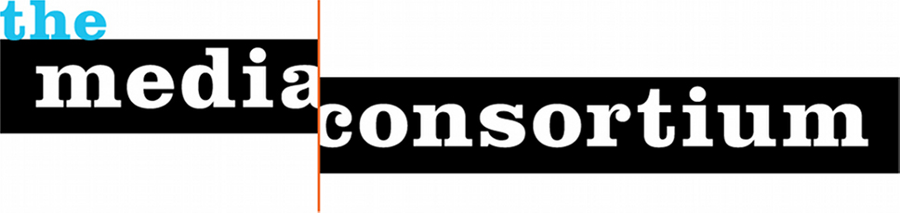Media Consortium Coordinating Committee, 2015

Chair:
Maya Schenwar, Editor-in-Chief, Truthout

Antoinette June, Web Editor, Free Speech TV

Jo Ellen Green Kaiser, TMC Executive Director

Steve Katz, Publisher, Mother Jones

Sharon Kyle, Publisher, LA Progressive

Maureen Nandini Mitra, Managing Editor, Earth Island Journal

Rory O’Connor, Founder, Globalvision

Lisa Rudman, Executive Director, Making Contact

Joseph Smooke, Co-Founder, People.Power.Media

