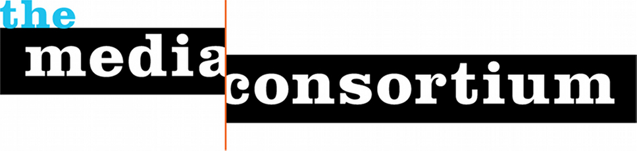Media Consortium Coordinating Committee, 2013

Chair:
Maya Schenwar, Executive Director, Truthout

Eric Galatas, Program Director, Free Speech TV

Jo Ellen Green Kaiser, TMC Executive Director

Steve Katz, Publisher, Mother Jones

Sharon Kyle, Publisher, LA Progressive

Maureen Nandini Mitra, Managing Editor, Earth Island Journal

Rory O’Connor, Founder, Globalvision

Lisa Rudman, Executive Director, Making Contact

Shay Totten, Communications Director and Employee Owner, Chelsea Green

