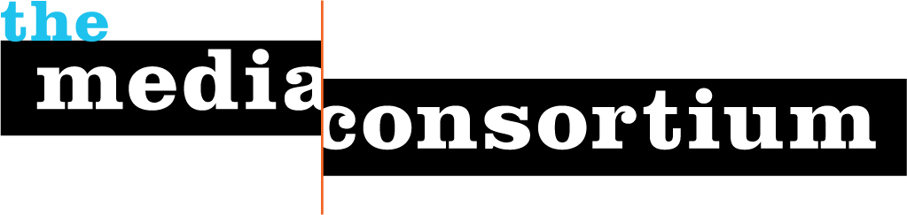
The Media Consortium: Board Members and Affiliations
Governance
Currently, The Media Consortium is a project of the Foundation for National Progress, the 501c3 entity that also publishes Mother Jones magazine. While the FNP board of directors has ultimate fiduciary responsibility for the project, a coordinating committee annually elected by participating members oversees The Consortium’s activities. The coordinating committee is a diverse group, representative of the media outlets that make up The Media Consortium. 2009 committee members include:

Jay Harris: Co-chair
Publisher and president, Mother Jones
Rinku Sen: Co-Chair
Publisher, ColorLines
Julie Bergman-Sender
Principal, Balcony Films
Lark Corbeil
Executive Director Public News Service
Ann Friedman
Deputy Editor, The American Prospect
Andrew Golis,
Deputy Publisher, Talking Points Memo
Carol Jenkins
Executive Director, Women's Media Center
Linda Jue
G.W. Williams Center for Independent Media
Steve Katz
Vice President, Mother Jones
Roberto Lovato
East Coast director, New America Media
Kim Spencer
Executive director, LinkTV
Katherine Spillar
Executive Editor, Ms. Magazine

The Media Consortium: Staff
Tracy Van Slyke has dedicated much of her career as a journalist, communications professional and media producer to building a strong independent media infrastructure. As the Program Director of The Media Consortium, she works to organize effective partnerships and innovative projects that will change the terms of the American political and cultural debate as well as create a cooperative infrastructure that supports a sustainable future for independent media.

Van Slyke is the former publisher of In These Times magazine, a national, award-winning monthly magazine of progressive news, analysis and cultural reporting. In 2005 and 2006, she and Jessica Clark co-authored the landmark articles on strengthening the progressive media landscape including, “Making Connections: Why is the news so bad? What can progressives do to fix it?” and “Welcome to the Media Revolution: How today’s media makers are shaping tomorrow’s news.”

Prior to joining In These Times, she was the Communications Director for the National Training and Information Center. In 2000 she was a fellow at Knight Ridder’s Washington D.C. bureau during the 2000 presidential campaign and covered national politics and events. She is also the co-editor of Build the Echo, and co-authoring a book on the impact of the progressive media on the political and media landscape from 2004 to 2008. (2009, The New Press). Van Slyke is also on the leadership council for the Progressive Communicator’s Network, and serves on the board of the National Training Information Center.

Erin Polgreen is a Senior Program Associate for The Media Consortium. From 2005-2007, she was the Associate Publisher for In These Times, where she managed advertising, marketing, event planning, and other outreach initiatives. Prior to working at In These Times, Erin served with City Year Chicago, an Americorps program, where she co-led a team of literacy tutors at an elementary school on the West side of Chicago. She is an active member of Chicago’s cycling community and regularly volunteers with West Town Bikes, a Chicago-area non-profit.

Becki Scholl is a Program Assistant at The Media Consortium. She is a former intern of In These Times magazine. She graduated from the University of Illinois at Chicago with an English degree. When she's not working for The Media Consortium, you can find her serving at Kuma's Corner.
Andrew Golis (potential leader of II Labs project)
Andrew Golis is the Deputy Publisher of talkingpointsmemo.com and all the TPM Media blogs.

TPM’s blogs are widely regarded as among the most innovative and influential political blogs in the country. Their groundbreaking work has been lauded in publications like the New York Times, GQ, and the Columbia Journalism Review. This past February, TPM Media was the first web-only news operation to receive the George Polk Award for its reporting on the US Attorney Scandal.

As Deputy Publisher, Andrew manages the design, monetization and distribution of all of TPM’s content. His job is to make sure that the amazing work done by TPM’s editorial staff finds both a direct and distributed audience and brings in the revenue necessary to continue to scale up TPM’s rapidly expanding operation.

Previously, he was an Associate Editor at TPM running TPMCafe.com, TPM’s community blog for discussions of politics, books, culture and activism. He’s worked in Democratic politics as a Staff Organizer for Howard Dean’s campaign for the presidency and as the Assistant Training Director for the Democratic National Committee. He also played an advisory role in designing and launching the Causes application for facebook.com, led the design and launch of Predict06.com, and has consulted for a handful of small web publishers.

Andrew studied social theory and American political history at Harvard College, where he ran a variety of campus campaigns and founded the Harvard Progressive Advocacy Group and the campus progressive political blog CambridgeCommon.com.

