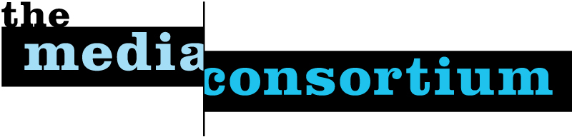

About The Media Consortium
In early March 2005, two dozen leaders from the worlds of independent print, radio, television, and Internet answered a call from Mother Jones magazine, The Nation, and The American Prospect, to discuss “Independent Media and the Future of Democracy.” It was the first time in at least a decade that independent media content producers and distributors had come together to talk about how to strengthen our effectiveness.
We continued the conversation through 2005, expanding the participants to include many more media content organizations. Our goal: to figure out how a network of progressive independent media organizations could address two challenges we all face:

- How to amplify independent journalism's voice in the broader public debates over the crucial political and social issues of our day;

- And how to navigate our way through the next wave of profound technological change - change that is reshaping the media business, not to mention redefining the practice of journalism itself.

Answering these two questions, we concluded, depended on achieving three goals:

- Deepening and broadening the connections among progressive independent media organizations, across all platforms, as well as between our organizations and other partner networks and organizations.

- Making long overdue basic investments in core infrastructure - investments that would give us the capacity to function effectively in this new, more connected world. Some fundamental sector-wide questions needed to be answered, such as: how big is our audience? Who are they? How do we better position our media outlets – and the audiences we serve – in the minds of opinion shapers and “influentials?” Can we make joint investments in training, technology sharing, advertising and promotion, and (not least) our own ability to communicate effectively with one another?

- Collaborating together to amplify our voice, so that we fulfill our role in a democracy as a vibrant, fact-based, community of independent journalism that educates, informs, and, in the end, engages people to act as citizens in creating the world to which we all aspire.

In early 2006, we organized The Media Consortium (in the words of our mission statement) to:
“to amplify our voices; increase our collective clout; leverage our current audiences and reach out to new ones; attract financial resources; strengthen and transform our individual businesses and our sector’s position in a rapidly changing media and political environment; and redefine ourselves and progressivism for a new century.”

From the very beginning we have seen The Media Consortium as a multi-platform network; the participating members include some of the leading independent magazines in the country; satellite television networks; radio networks and content producers; book publishers; film production units; and “pure play” online media operations. The Media Consortium has innovation and change built into its DNA: to foster change among its members, and to accomplish together what no single organization could do on its own.

The Media Consortium is now a network of now a network of 43 leading independent journalism organizations in print, online, on television, and on the radio. The participating members in The Media Consortium as of this date are:

Afro-Netizen
Air America Radio
Alternet
The American Prospect
Balcony Films
Brave New Films
Berrett-Koehler Publishers
Chelsea Green Publishers
Colorlines
Democracy Now
Free Speech TV
GlobalVision/Media Channel
GoLeftTV
Grist.org
Hightower Lowdown
In These Times
LinkTV
Media Venture Collective
Mother Jones
Moving Ideas, a project of Care2
Ms. Magazine
The Nation
Nation Institute
National Alliance for Media
Arts and Culture (NAMAC)
National Radio Project
New America Media
New Press
The Progressive
Public News Service
Raw Story
RealTV/IWT
Salon Media Group, Inc.
Sojourners
South End Press
Talking Points Memo
Truthdig
Warandpiece
The Washington Monthly
Women's Media Center
Workers Independent News
YES! magazine
The Young Turks, Air
America

