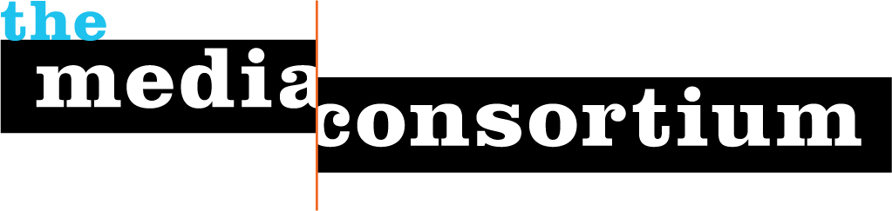
The Media Consortium Mission Statement

We, the makers and providers of progressive, independent journalism, declare out intent to form among ourselves a new nonprofit association, The Media Consortium. Its purpose will be to amplify our voices; increase our collective clout; leverage our current audience and reach out to new ones; transform our sector’s position in a rapidly changing media and political environment; and redefine ourselves and progressivism for a new century.

We will pursue these goals through such concrete and practical efforts as are more effective when undertaken jointly. We believe it is possible and necessary to seize the current moment and change the debate in this country. Therefore, the mission of the Media Consortium is of vital importance for the health of American democracy.

