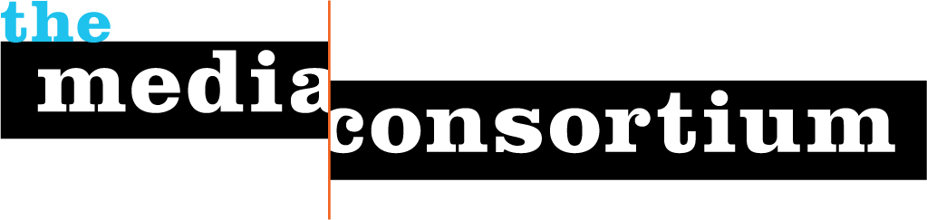
About The Media Consortium
In early March 2005, two dozen leaders from the worlds of independent print, radio, television, and Internet answered a call from Mother Jones magazine, The Nation, and The American Prospect, to discuss “Independent Media and the Future of Democracy.” It was the first time in at least a decade that independent media content producers and distributors had come together to talk about how to strengthen our effectiveness.
We continued the conversation through 2005, expanding the participants to include many more media content organizations. Our goal: to figure out how a network of independent media organizations could address two challenges we all face:
• How to amplify independent journalism's voice in the broader public debates over the crucial political and social issues of our day, and
• How to navigate our way through the next wave of profound technological change - change that is reshaping the media business, not to mention redefining the practice of journalism itself.
In early 2006, we organized The Media Consortium: “to amplify our voices; increase our collective clout; leverage our current audiences and reach out to new ones; attract financial resources; strengthen and transform our individual businesses and our sector’s position in a rapidly changing media and political environment; and redefine ourselves and progressivism for a new century.”
The Media Consortium is now a network of 45 leading independent journalism organizations in print, online, on television, and on the radio. The participating members in The Media Consortium as of this date are:
Afro-Netizen
Air America Radio
AlterNet
American News Project
The American Prospect
Balcony Films
Brave New Films
Berrett-Koehler Publishers
Center for Independent Media
Chelsea Green Publishers
ColorLines
Democracy Now
Free Speech TV
GlobalVision/Media Channel
GoLeftTV
Grist.org
Hightower Lowdown
In These Times
LinkTV
Media Venture Collective
Mother Jones
Ms. Magazine
The Nation
Nation Institute
National Alliance for Media
Arts and Culture (NAMAC)
National Radio Project
New America Media
New Press
New Voices in Independent Journalism
The Progressive
Public News Service
Raw Story
RealTV/IWT
Regional News Network
Salon Media Group, Inc.
Sojourners
South End Press
Talking Points Memo
Texas Observer
Truthdig
Warandpiece
The Washington Monthly
Women's Media Center
Workers Independent News
YES! Magazine
The Young Turks, Air America
From the very beginning we have seen The Media Consortium as a multi-platform network; the participating members include some of the leading independent magazines in the country: satellite television networks, radio networks and content producers, book publishers, film production units, and online-only media operations.
Within its short lifetime, The Media Consortium has accomplished significant victories. It has broken down many historical barriers blocking communication and collaboration between members of the progressive media. It has acted as a hub for member groups to engage in projects that fill holes around editorial efforts, identify new market opportunities, and develop new revenue opportunities that benefit both the individual organizations and the sector as whole.

