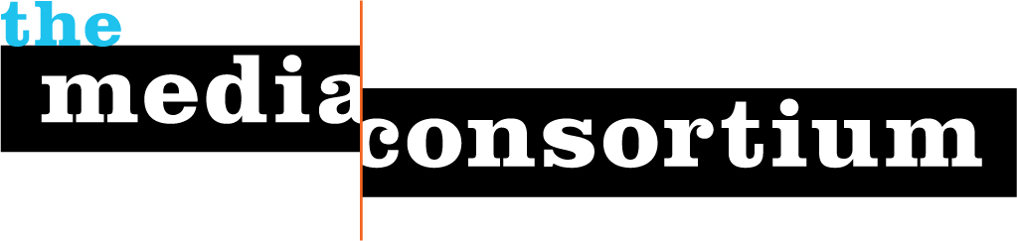

For Immediate Release: April 5, 2011 Contact: Erin Polgreen, Managing Director
erin@themediaconsortium.com/312.841.0553
Twitter: @tmcmedia

The Media Consortium Welcomes New Executive Director, Jo Ellen Green Kaiser

CHICAGO—The Media Consortium, a national network of leading independent media outlets, is pleased to announce the appointment of Jo Ellen Green Kaiser as its new Executive Director. Kaiser comes to The Media Consortium (TMC) from Zeek Media, Inc., where she served as Executive Director and Editor-in-Chief of Zeek magazine.

“I’m excited to have the opportunity to lead TMC when the very concept of media is being redefined,” says Kaiser. “We will focus on developing and strengthening a diverse, independent, progressive media sector that provides vital reporting on the stories beyond the mainstream, educates users about the meaning of those stories, and connects users to new technologies so they can become a part of the story themselves.”

“We’re very pleased to welcome Jo Ellen Green Kaiser to the TMC team,” said TMC Chair Rinku Sen, publisher of Colorlines.com. “Media today faces significant challenges, from the rapid pace of technological change to the changing tides of politics sweeping the world, but it’s also a time of tremendous opportunity. Jo Ellen is uniquely suited to grasp this opportunity.”

Kaiser brings over fifteen years of experience in independent media to The Media Consortium, including a stint as consultant to the Independent Press Association. “Our members fulfill the critical role of media in a democracy. Mainstream media today is top-down media. It’s a bunch of pundits telling us what to think,” says Kaiser. “Members of the Media Consortium go out and listen to what’s really happening at the grassroots level.”

Steve Katz, TMC coordinating committee member and publisher of Mother Jones agrees. “We just saw with the Wisconsin protests that we can’t depend on mainstream or commercial media to cover the really important stories. TMC plays a key role in strengthening a growing network of independent media organizations. We’re confident that Jo Ellen Green Kaiser will be able to lead the organization to the next stage of its development.”

Along with welcoming Kaiser as the new Executive Director, the Media Consortium is pleased to announce that Associate Director Erin Polgreen has been promoted to Managing Director, and will lead strategic program and resource development for Media Consortium members. Kaiser replaces Tracy Van Slyke, who is consulting with a variety of grassroots organizations and media producers to identify and implement strategic opportunities to evolve for the 21st century media environment.

About us
The Media Consortium is a national network of leading, progressive independent media. Our mission is to amplify independent media’s voice, increase our collective clout, leverage our current audience and reach new ones. Our members include magazines, web sites, television networks, radio, and film producers.
www.themediaconsortium.org

