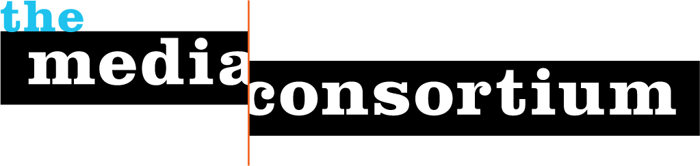

For Immediate Release: April 5, 2011 Contact: Erin Polgreen, Managing Director
erin@themediaconsortium.com/312.841.0553
Twitter: @tmcmedia

Meet Jo Ellen Green Kaiser


Jo Ellen Green Kaiser is the executive director of The Media Consortium.

Passionate about mission-driven independent media, Jo Ellen has worked for a succession of independent magazines, including stints as Managing Editor and Associate Publisher of Tikkun, Publisher of LiP: Informed Revolt, and Executive Director and Editor-in-Chief of Zeek. She is driven by a belief that democratic societies thrive only when their members have access to accurate information and informed opinion.

A leading figure in Jewish media, Jo Ellen is an expert on the Jewish social justice movement. She is the co-editor of Righteous Indignation: A Jewish Response to Justice (Jewish Lights) and co-led the Righteous Indignation Project. She has written about Jewish social justice for a number of publications, including The Jewish Daily Forward, Sojourners, Tikkun and Interfaithfamily.com.

Jo Ellen received a B.A. at Yale Unviersity (1984) and a Ph.D. in English from University of California, Berkeley (1992). She taught modern poetry, women’s studies and literary theory for six years at the University of Kentucky before leaving academia for media. Jo Ellen grew up in Oak Park, Illinois, and makes her home now in San Francisco.

About TMC
The Media Consortium is a national network of leading, progressive independent media. Our mission is to amplify independent media’s voice, increase our collective clout, leverage our current audience and reach new ones. Our members include magazines, web sites, television networks, radio, and film producers.
www.themediaconsortium.org

