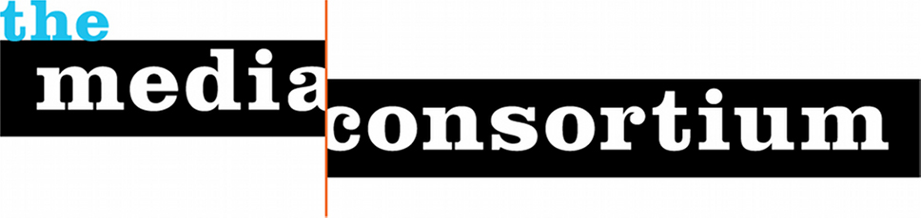

The Media Consortium’s Annual Conference: TMC2017

Since 2009, the 80 member outlets of the Media Consortium (TMC) have gathered annually to develop peer-to-peer relationships at their annual conference. The schedule for last year’s conference can be viewed at http://www.tmcmedia2016.org/

TMC2017 will be no different. Over two days, Media Consortium members will:

- Exchange best business practices through sessions on donor engagement, salesforce customization, impact measurement and planning for racial equity;
- Attend hands-on workshops, such as one planned on making shareable virtual reality on the cheap;
- Develop editorial collaborations around issues of mutual interest; and
- Hear from community leaders forecasting issues likely to hit the next year’s news cycle.

Media Consortium conferences are open to the public. We specifically invite members of sister associations INN, AAN, LION, NFCB and ACM to attend our conference at the discounted cost offered to Media Consortium members, and we provide deep discounts to members of local community and ethnic media that wish to attend.

We expect 120 attendees at TMC2017. We require a minimum of three spaces, one large enough to hold 80 attendees banquest style, one able to hold 50 attendees theater style, and then 1-2 other spaces sizes for 20-30 attendees, theater style.

Questions about TMC2017 can be sent to

Jo Ellen Green Kaiser, Executive Director
joellen@themediaconsortium.com
415.878.3862 | @jgksf

