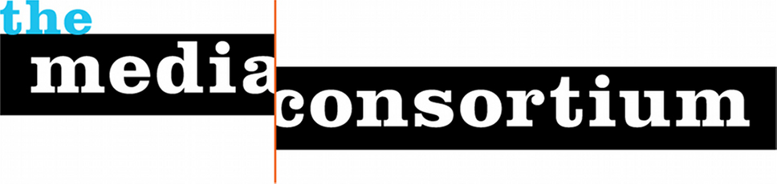
Contact: Jo Ellen Green Kaiser; 415-878-3862
joellen@themediaconsortium.com
joellen@themediaconsortium.com

FOR IMMEDIATE RELEASE

INDEPENDENT MEDIA SECTOR GRABS MAJOR 2012 JOURNALISM AWARDS
Sector’s maturity seen with prizes across outlets

San Francisco, CA—June 20, 2012. Independent media outlets won 6 top journalism awards this month alone, including an Edward R. Murrow award, a Hillman Prize, and the 2012 Martha Gellhorn Prize.

This June award sweep demonstrates the growing impact of the independent media sector, as independent outlets replace corporate-held news outlets as go-to sources for investigative and feature reporting. According to Media Consortium Executive Director Jo Ellen Green Kaiser, “Independent media outlets increasingly are filling holes in the corporate media ecosystem; we are mission-driven to provide exactly this kind of in-depth coverage.”

This year’s Edward R. Murrow Award in Online News Operation: Audio Investigative Reporting went to The Lens and the George Washington Williams Center for Independent Journalism for a story by Bob Butler and Jessica Williams on one woman’s efforts to rebuild after Hurricane Katrina.

The 2012 Martha Gellhorn Prize for Journalism was awarded to Gareth Porter for his reporting on the Obama administration’s military strategy for Truthout and the Interpress News Service.

The 19th annual Media for a Just Society Awards recognized the National Radio Project’s Andrew Stelzer, Kyung Jin Lee and Daniel Gordon for their work on Making Contact's report on gang injunctions..

Mother Jones, together with UC Berkeley’s Investigative Journalism Program, received the first International Data Journalism Award for Trevor Anderson’s reporting on FBI informants in U.S. Muslim communities. The same story also received The Molly Ivins National Journalism Prize.

Reporter Seth Freed Wessler at Colorlines.com received the 2012 Hillman Prize for Web Journalism for his reporting on U.S. citizen children whose parents are deported by the U.S. Immigration Service.

Six of these award-winners are members of the Media Consortium, a national network of independent media outlets. For more information, please contact
Jo Ellen Green Kaiser, 415-878-3862; joellen@themediaconsortium.com

