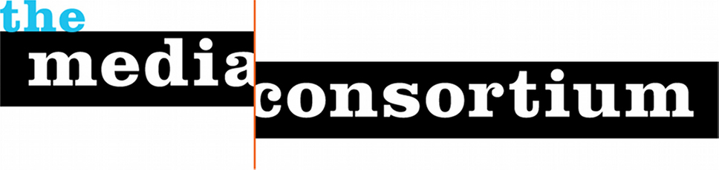

Janaury 7, 2015

The Media Consortium strongly condemns the attack on Charlie Hebdo, an independent magazine based in Paris.

Free speech is a human right. The ability to speak freely allows us to name ourselves and tell our own story. It allows us to say who we are—and who we are not.

Free speech can hurt—certainly, the brave cartoonists and writers of Charlie Hebdo intended their speech to be its own weapon. We dishonor their memory if we don’t understand that they used speech to fight a proxy war against Islamic fundamentalism. Their opponents, however, chose the coward’s way out; they chose to end that argument by silencing the voices of Charlie Hebdo with guns.

What’s even sadder is that the writers of Charlie Hebdo are not alone. In 2014 alone, over 100 journalists were killed around the world for speaking freely about what they saw. Many more have been killed—both journalists and civilians alike—for voicing their opinions.

The shooting at Charlie Hebdo will only cause us to redouble our efforts as independent journalists to tell the stories we see; to speak our truths, no matter how controversial; and to refuse to be bullied.

We believe, with Gandhi and Martin Luther King Jr, that speech will always eventually prevail over violence. The deaths of Stephane Charbonnier, Bernard Maris, Jean Cabu, Georges Wolinski, Bernard Verlhac and their colleagues will not have been in vain.

#JesuisCharlie

